Anthony Cunningham

Research Data Management

Professor Eric Foster

**Homework 3**

#1

* Problem 1;

**DATA** school;

DO n = **1** TO **6**;

studentid = **1000**;

INPUT age quiz : $1. midterm final;

studentid = studentid + n;

IF age = **11** THEN gradeLevel = "5th";

ELSE IF age = **12** THEN gradeLevel = "6th";

ELSE gradeLevel = "7th";

IF quiz = "A" THEN quizGrade = **100**;

ELSE IF quiz = "B" THEN quizGrade = **90**;

ELSE IF quiz = "C" THEN quizGrade = **80**;

ELSE IF quiz = "D" THEN quizGrade = **70**;

ELSE quizGrade = **65**;

course = (quizGrade\***0.20**) + (midterm\***0.30**) + (final\***0.50**);

KEEP studentid gradeLevel course;

OUTPUT;

END;

DATALINES;

12 A 92 95

12 B 88 88

13 C 78 75

11 A 92 93

12 F 55 62

13 B 88 82

;

**RUN**;

**PROC** **PRINT** DATA=school;

**RUN**;

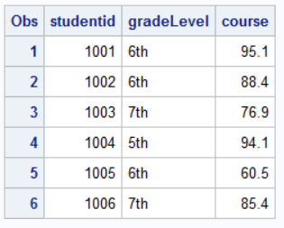

#2

* Problem 2;

**DATA** millionaire;

interest = **0.05**;

total = **100**;

DO UNTIL (total >= **1000000**);

total = total + interest*total;

year + **1**;

END;

**RUN**;

**PROC** **PRINT** DATA=millionaire;

**RUN**;

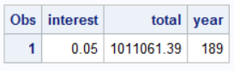

* It will take 189 years to accrue $1 million in one’s bank account.

#3

* Problem 3;

**DATA** priceyBikes;

SET hw3.bicycles;

IF Model = "Road Bike" THEN DO;

IF UnitCost < **2500** THEN DELETE;

END;

ELSE IF Model = "Hybrid" THEN DO;

IF UnitCost < **600** THEN DELETE;

END;

ELSE DELETE;

**RUN**;

**PROC** **PRINT** DATA=priceyBikes;

**RUN**;

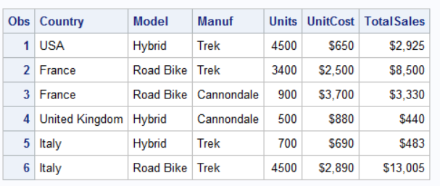

#4

* Problem 4;

**DATA** odds;

DO p = **0.1** TO **0.9** BY **0.1**;

odds = p/(**1** - p);

logit = LOG(odds);

OUTPUT;

END;

**RUN**;

**PROC** **PRINT** DATA=odds;

**RUN**;

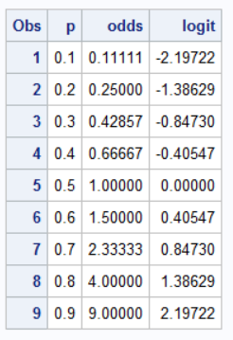

#5

**DATA** avgspeedread;

SET WORK.speedread;

BY method;

IF method = "A" THEN DO;

totalA + score;

avgscore = (totalA/**10**);

END;

ELSE IF method = "B" THEN DO;

totalB + score;

avgscore = (totalB/**10**);

END;

ELSE IF method = "C" THEN DO;

totalC + score;

avgscore = (totalC/**10**);

END;

IF (LAST.method);

KEEP method avgscore;

**RUN**;

**PROC** **SORT** DATA=avgspeedread;

BY avgscore;

**PROC** **PRINT** DATA=avgspeedread;

**RUN**;

